**Mone-G**

**SOLMAN CHARM Normal Change**

**Contents**

**Version History** 2

**Introduction** 4

**Section 1** 5

## **Version History**

|  |  |  |  |  |
| --- | --- | --- | --- | --- |
| Version No. | Author | Reviewed by | Changes | Released on |
|  |  |  |  |  |
|  |  |  |  |  |
|  |  |  |  |  |

# GENERAL INFORMATION

The purpose of this document is to act as an End user guide for the ChaRM Change Document application.

The change document is driven by specific documents within the ChaRM. Each Change request within ChaRM will create change documents:

1. Change Document (CD) - The CD is a child document of the RFC. The purpose of the Change Document is to anchor, monitor and drive the technical changes (that arise because of the RFC) through the Development, Quality and Production systems.

Sections below explain the process cycle of each document.

There are 8 steps to processing the Change Document

* Access the Change Document (CD)
* Assign Resources
* Change CD status to In Development
* Transport Creation and processing
  + Creating a New Transport Request
  + Assigning and Decoupling existing Transport Request
* Release task
* Developer routing the request to Change Manager for initiating test
* Performing QA Testing
* Change Manager’s Approval for Production import
* Import of TR into Production by Basis

**The User Roles for processing Change Documents are listed below:**

* Developer
* Tester
* BASIS
* Change Manager

**URL to access CHARM**

<https://vhmcys01ci.pce.sharedom.net:50001/sap(bD1lbiZjPTEwMCZkPW1pbg==)/bc/bsp/sap/crm_ui_start/default.htm?sap-client=100&sap-language=EN>

## 1.1 Access the Change Document (CD)

Once change document is created open the RFC -> Go to Scope field and click on the appropriate change document number as shown below. Change Document get opened.

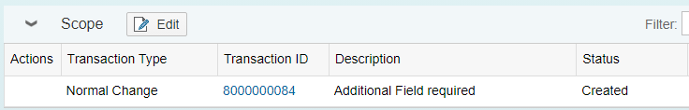

Click on Transaction ID

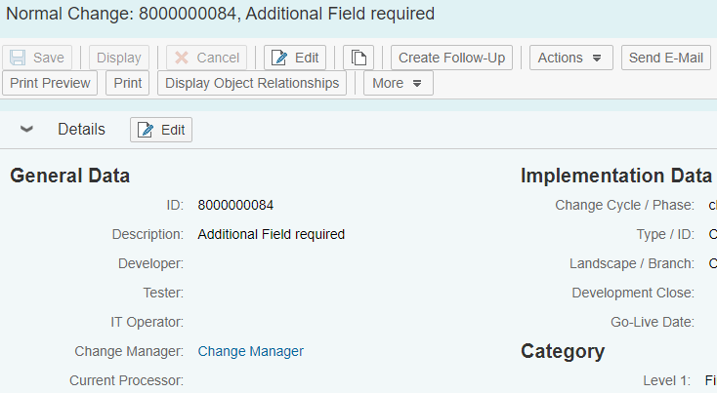

## 1.2 Assign Resources

In the Normal Change document, assign resources (Developer, Tester, and Basis) for this change.

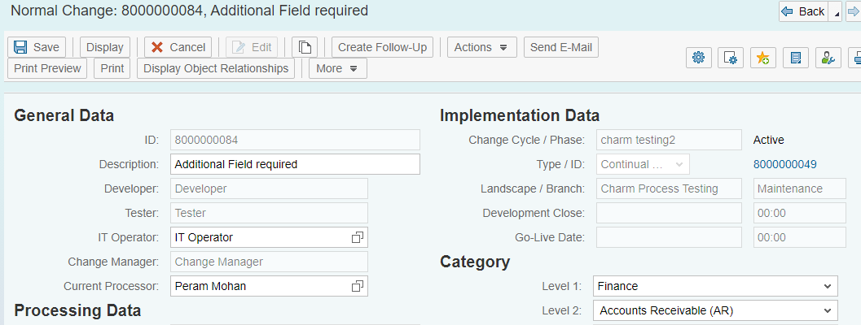

Assign Resource

## 1.3 Change CD status to In Development

Once resources are assigned, the Developer can start a build. Developer will set charm status to **‘In development’**. With this status, the system allows creation of a Transport request. The process is explained in detail below.

Select decision

Actions Set to “In Development”

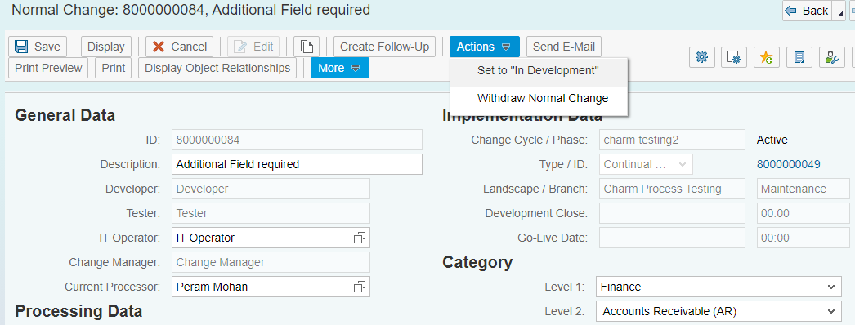

Status set to “In Development”

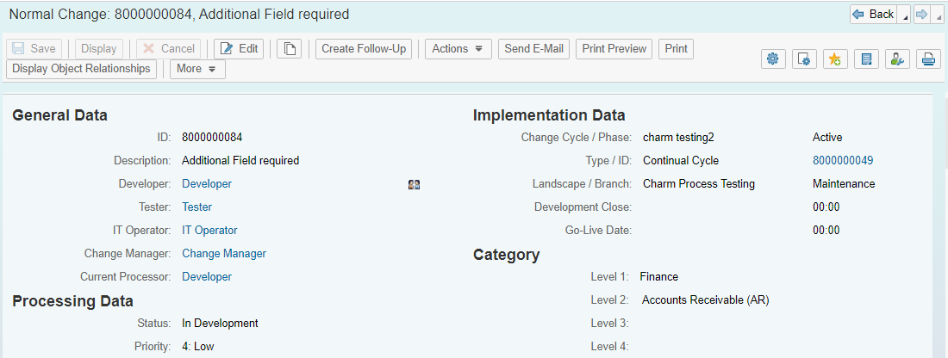

Status set to **“In Development”**

## 1.4 Create Transport Request

From Normal Change Document we can directly create Transport Request in S4HANA Development system.

Transport Management Create Transport Request

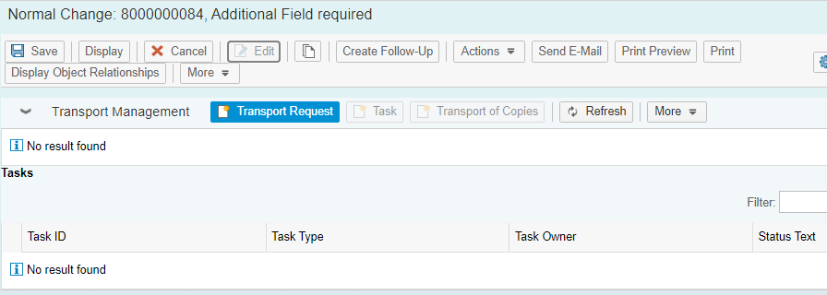

Create **Transport Request**

A pop up of create transport request window appears.

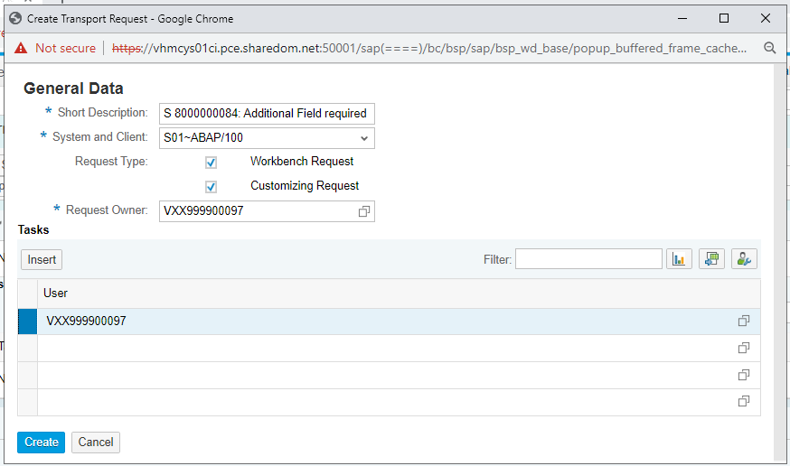

**4**

Click Crete

**3**

Change if TR Owner if required

**1**

**2**

Select Request Type

Follow the TR naming convention and select client

Short Description: Follow the TR naming convention

System and Client: Select the Client you want to create TR

Request Type: Workbench Request / Customizing Request

Request Owner: TR owner

The TR(Transport Request) gets created in the Managed system and displayed under transport management tab. As shown below.

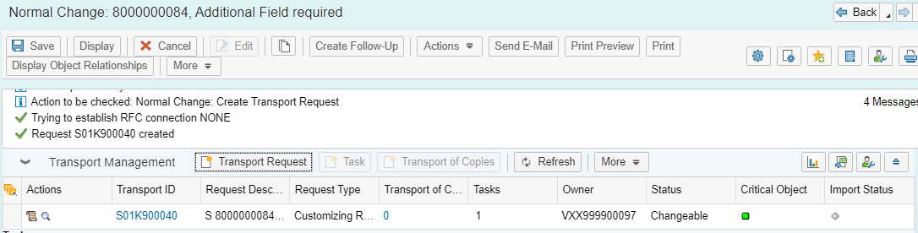

## 1.5 Assign Existing TR to Normal change document

### 1.5.1 Assign Transport Request

Transport Management More Assign Transport Request

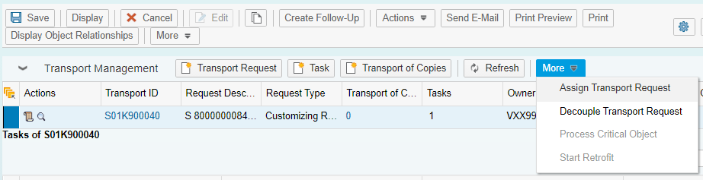

**Assign Transport Request**: To add existing TR to CHARM (Only Modifiable TR’s)

**Decouple Transport Request**: To remove TR from CHARM (Only Modifiable TR’s)

A pop up of assign transport request window appears.

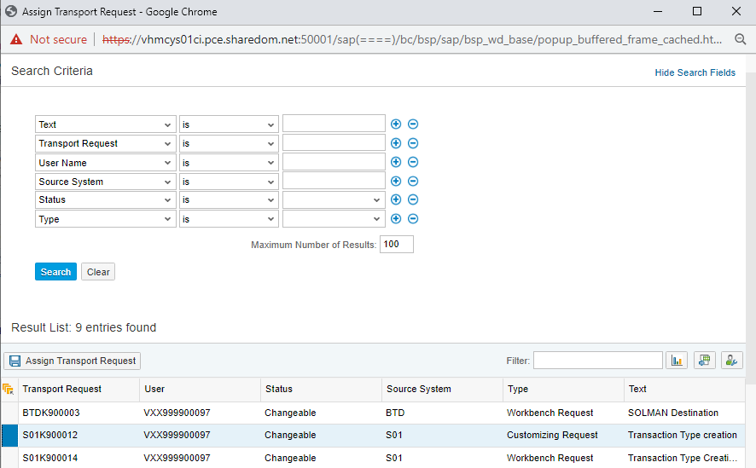

**3**

Assign Transport Request

**2**

Search

**1**

Input section for specific search (Optional)

Select TR(s)

Transport request assigned to Normal Change document.

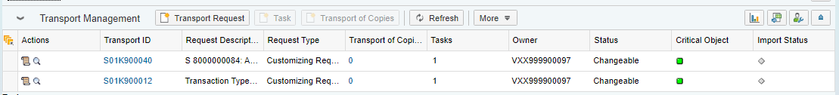

### 1.5.2 Decouple Transport Request

Transport Management Select TR More Decouple Transport Request

**2**

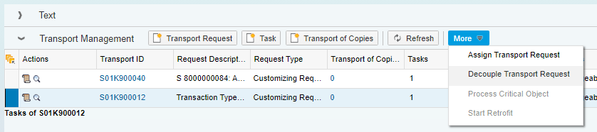

**1**

Select TR(s)

Decouple TR

Confirm TR Decoupling from CHARM, only Changeble TR’s can decouple

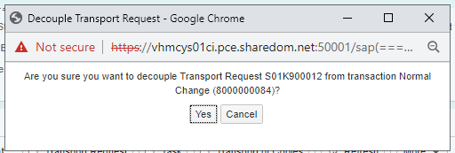

Select decision

## 1.6 Capturing change in Transport Request

Access the development system (GD2), and perform the changes/development/configuration/built, while saving your changes (customization or workbench), system prompts for TR(Transport request), instead of creating a new TR, select the TR created in SOLMAN through Own requests option. Pls see below.

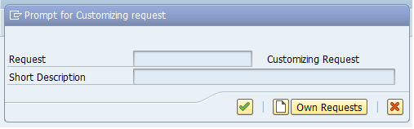

**1**

Click on **Own Requests**

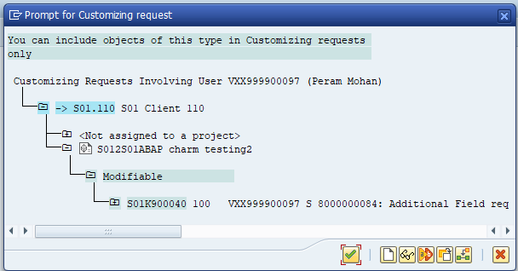

**2**

Select the TR and click OK

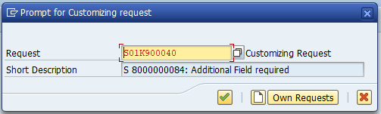

Ok to capture change in TR

**3**

**Release Task**: Once configuration/development completed and captured into a TR, Goto SE10 in managed system (GD2), select the TR and release It’s task (**MainTR remain unreleased).**

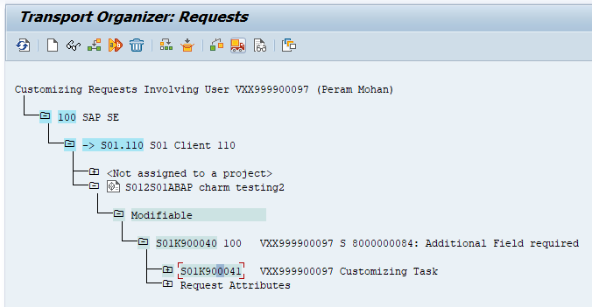

Release the Task

Select **Task**

**2**

**1**

## 1.7 Pass Normal change to Test

After releasing the task, pass normal change to test, CHARM creates TOC (Transport of Copy) out of released task, and import TOC into QAS system.

Actions Pass Normal Change to Test Save

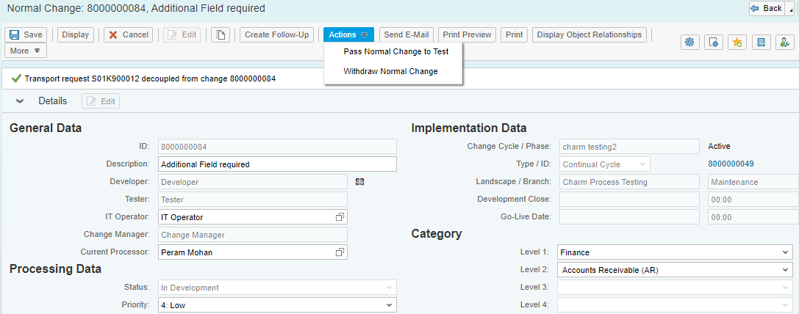

Select decision

Status changes to **To Be Tested**

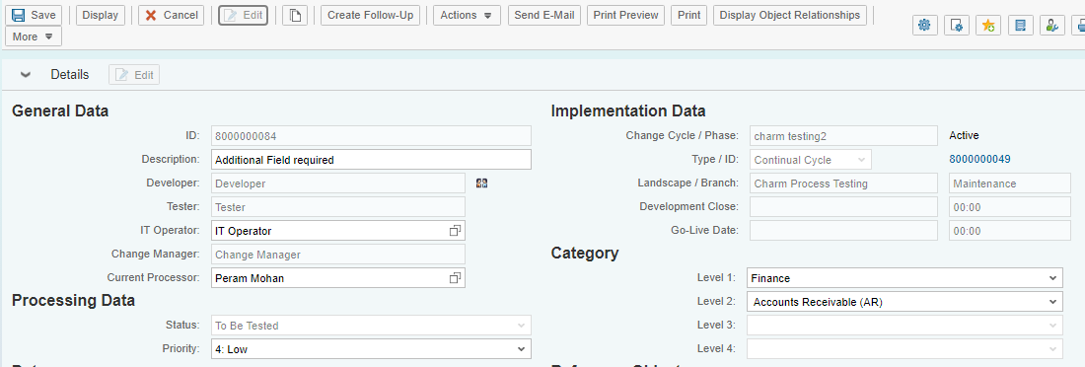

at backend TOC created, released and imported into QA system.

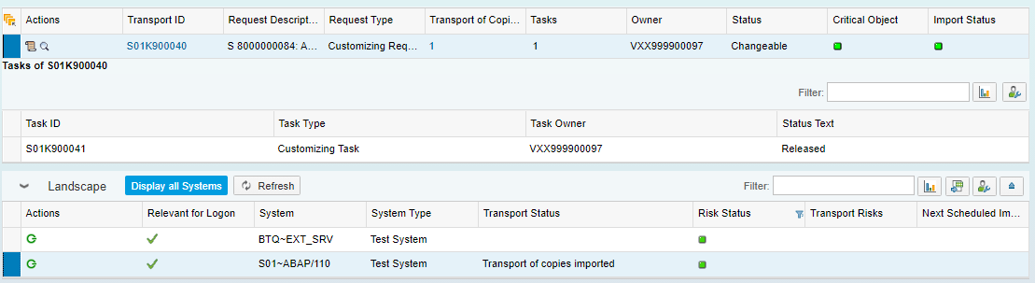

TOC created

TOC released and imported automatically into QAS

## 1.8 Executing QA Test

Once Status set to “**To be Tested”**,tester will performQA test and updates the test result, in case test failed send back to **in development**, if test pass **Confirm Successful Test**

**Reset Status to “In Development”** (Refer to section 1.3)

Actions Confirm Successful Test Save

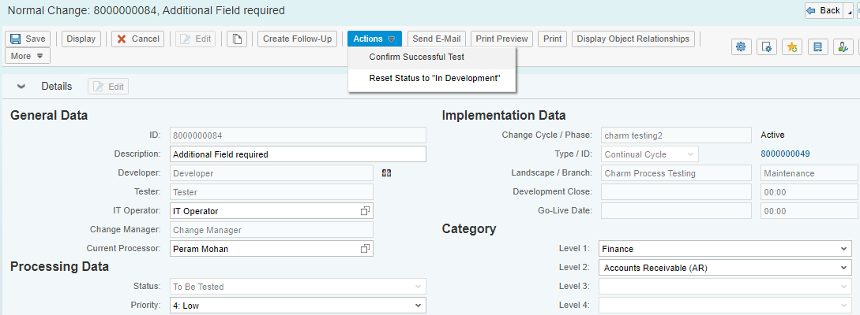

Select decision

Status set to Successfully Tested

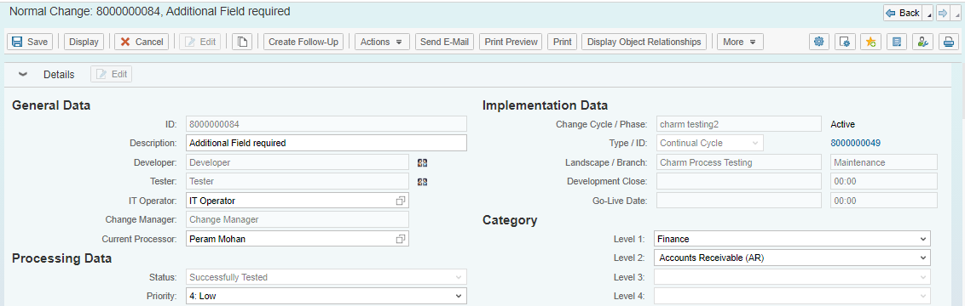

At backend system releases Main TR from development and added to

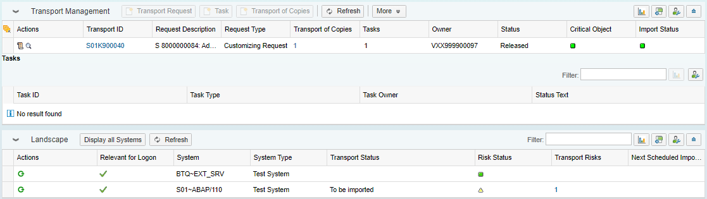

Main TR added to QAS import queue for import

Main TR get released

Main transport request imported into QAS system and added to PRD import queue

## 1.9 Request for PRD Import.

Once UAT Test is successful Change manager authorize for PRD import, by running following action (**Authorize for Production).**

Actions Authorize for PRD Import Save

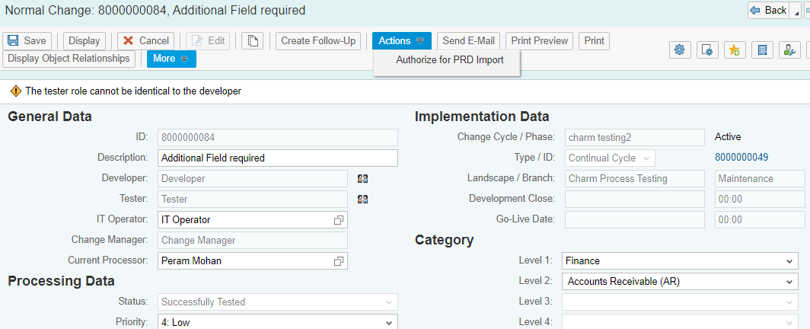

Select decision

Status Changes to **Authorized for PRD** I**mport**

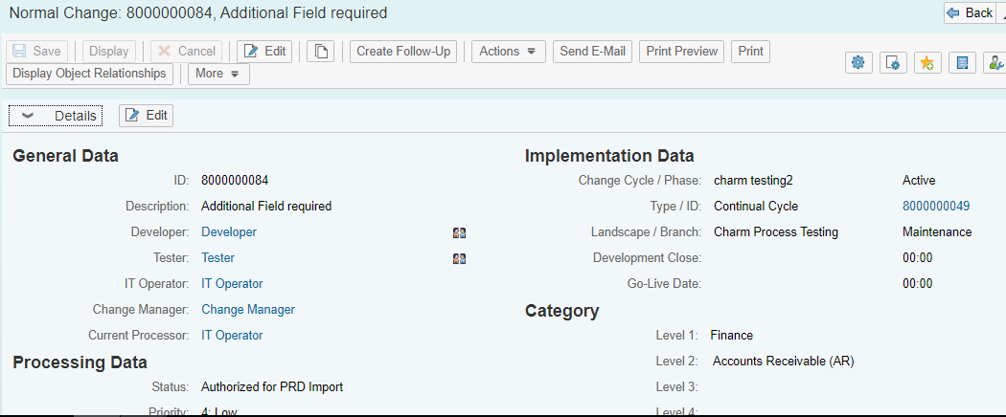

## 1.10 Import TR into PRD

Basis team can initiate the TR import through task list.

Actions Import Normal Change into Production Save

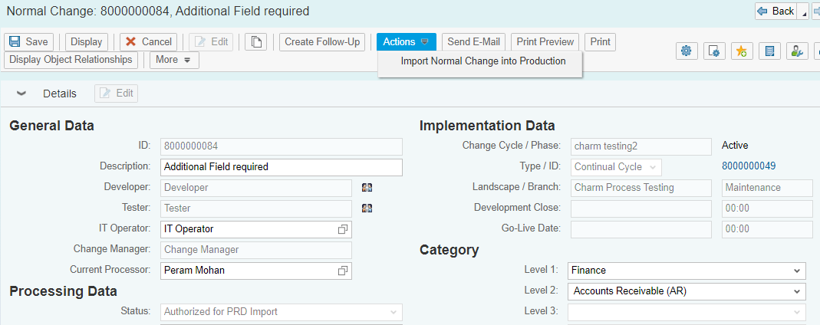

Status set to **Import into Production**

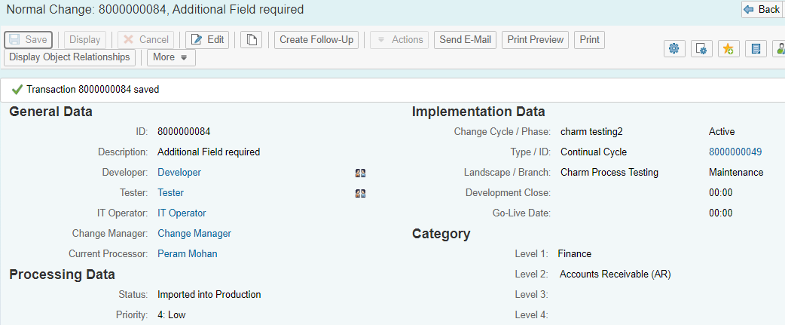

Once Normal change document status is set to **Import into Production,** no more changes allowed.